Proj overeview

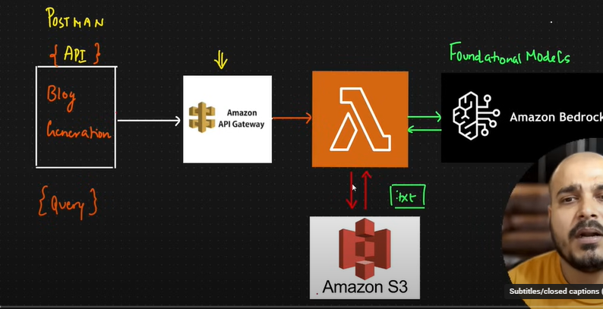

Bedrock

Get model access

Then click on deploy

Before tht The packages needed by lambda should be inside a folder called python and that python folder should be zipped. That thought zip can be in any name.

This zip file is added as something called a layer.So create a layer and add the zip file created above

Then create api gateway,route etc and hit the api

AWS SAGEMAKER

Document QnA project

